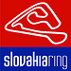
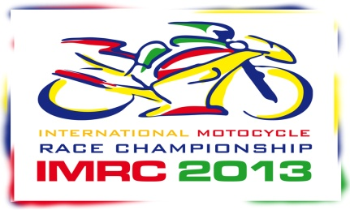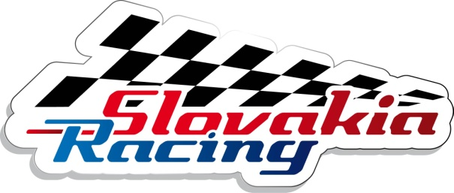
Timetable IMRC 2013
1.DAY
7:00 – 9:00 Administration/Technical control
9:00 – 9:20 MMSR 600,1000 Free training 0:20
9:20 – 9:40 SP 600,1000 Free training 0:20
9:40 – 10:00 Bike Promotion Free training 0:20
10:00 –10:20 MMSR 600,1000 Free training 0:20
10:20 –10: 40 SP 600,1000 Free training 0:20
10:40 – 11:00 Bike Promotion Free training 0:20

11:00 – 11:20 MMSR 600,1000 Free training 0:20
11:20 – 11:40 SP 600,1000 Free training 0:20
11:40 – 12:00 Bike Promotion Free training 0:20
----------------------------------------------------------------------------------------
12:00 – 12:30 Race BMW CUP
12:30 – 12:55 Timed practice CEC/GEEC
----------------------------------------------------------------------------------------
12:55 – 13:15 MMSR 600 Qualifying 0:20
13:15 – 13:35 MMSR 1000 Qualifying 0:20
13:35 – 13:55 SP 600,1000 Free training 0:20

13:55 – 14:55 Lunch Time

14:55 – 15:25 MMSR 600 Race (8 lap) 0:30
15:25 – 15:55 MMSR 1000 Race (8 lap) 0:30 ----------------------------------------------------------------------------------------------------------------------
2.DAY
9:00 – 9:20 MMSR 600,1000 Free training 0:20
9:20 – 9:40 SP 600,1000 Free training 0:20
9:40 – 10:00 Bike Promotion Free training 0:20
10:00 –10:20 MMSR 600,1000 Free training 0:20
10:20 –10:40 SP 600,1000 Free training 0:20
10:40 – 11:00 Bike Promotion Free training 0:20

11:00 – 11:20 MMSR 600,1000 Free training 0:20
11:20 – 11:40 SP 600,1000 Free training 0:20
11:40 – 12:00 Bike Promotion Free training 0:20

12:00 – 12:20 MMSR 600 Qualifying 0:20
12:20 – 12:40 MMSR 1000 Qualifying 0:20
12:40 – 13:00 SP 600,1000 Qualifying 0:20

13:00 – 14:00 Lunch Time

14:00 – 14:30 MMSR 600 Race (8 lap) 0:30
14:30 – 15:00 MMSR 1000 Race (8 lap) 0:30
15:00 – 15:30 SP 600 Race (8 lap) 0:30
15:30 – 16:00 SP 1000 Race (8 lap) 0:30

