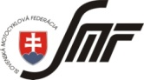
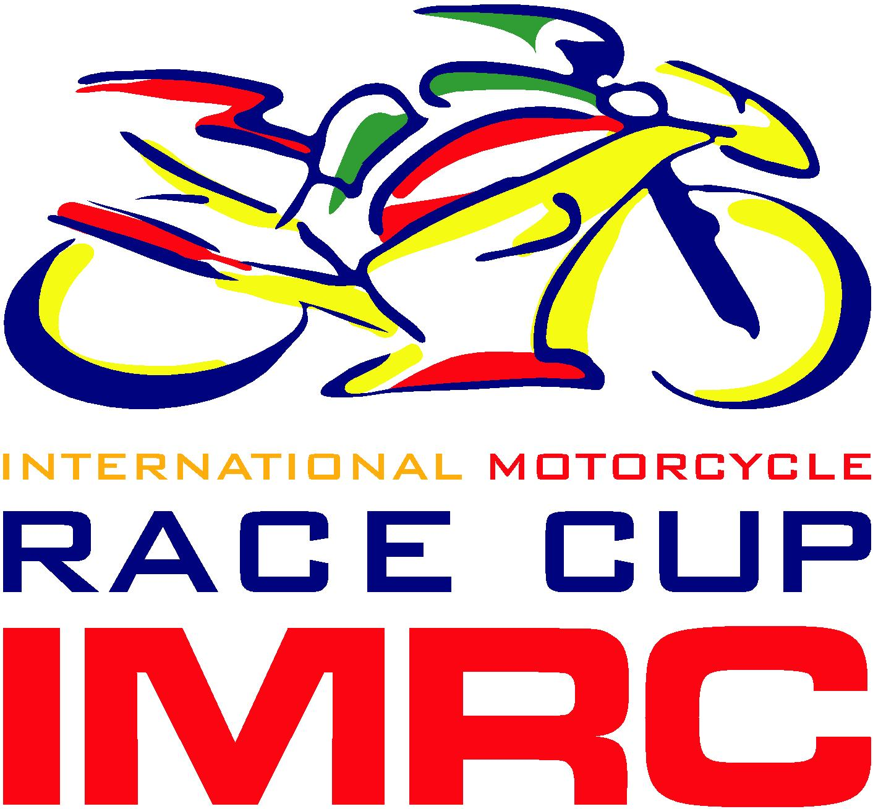
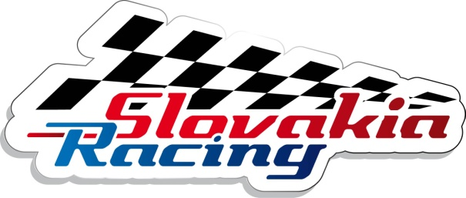
Timetable IMRC + Vintage 2014 – Version C
SATURDAY – 12.04.2014

08:30 – 08:50 B+D+C Free practice 0:20
08:50 – 09:10 IMRC CUP - 600 (SP, CC, PP Rookie) * Free practice 0:20
09:10 – 09:30 IMRC CUP - 1000 (SP, CC, PP Rookie)* Free practice 0:20
09:30 – 09:50 125/Moto3 – MM SR (MMSR, MGOB, MCR, MP) *, A1+A2 Free practice 0:20
09:50 – 10:10 SST, SSP 600 - MM SR (MMSR, MGOB, MCR, MP) * Free practice 0:20
10:10 – 10:30 SST1000 - MM SR (MMSR, MGOB, MCR, MP) * Free practice 0:20
10:30 – 10:50 SBK 1000 - MM SR (MMSR, MGOB, MCR, MP) * Free practice 0:20
10:50 – 11:10 DUCATI + 0 Parada Free practice 0:20
11:10 – 11:30 B+D+C Free practice 0:20
11:30 –11:50 IMRC CUP - 600 (SP, CC, PP Rookie) * Free practice 0:20
11:50 – 12:10 IMRC CUP - 1000 (SP, CC, PP Rookie) * Free practice 0:20
12:10 – 12:50 Lunch Break 12:50 – 13:10 125/Moto3 – MM SR (MMSR, MGOB, MCR, MP)*, A1+A2 Free practice 0:20
13:10 – 13:35 SST, SSP 600 - MM SR (MMSR, MGOB, MCR, MP)* Qualifying 1 0:20
13:35 – 14:00 SST1000 - MM SR (MMSR, MGOB, MCR, MP) * Qualifying 1 0:20
14:00 – 14:25 SBK 1000 - MM SR (MMSR, MGOB, MCR, MP) * Qualifying 1 0:20
14:25 – 14:45 DUCATI + 0 Parade Free practice 0:20
14:45 – 15:10 125/Moto3 – MM SR (MMSR, MGOB, MCR, MP)* Qualifying 0:20
15:10 – 15:35 IMRC CUP - 600 (SP, CC, PP Rookie) * Qualifying 0:20
15:35 – 16:00 IMRC CUP - 1000 (SP, CC, PP Rookie) * Qualifying 0:20
16:00 – 16:45 SST, SSP 600 - MM SR (MMSR, MGOB, MCR, MP)* Race 1 0:45
16:45 – 17:30 SST1000 - MM SR (MMSR, MGOB, MCR, MP)* Race 1 0:45
17:30 – 18:15 SBK 1000 - MM SR (MMSR, MGOB, MCR, MP)* Race 1 0:45
18:15 – 18:55 125/Moto3 – MM SR (MMSR, MGOB, MCR, MP) * Race 0:40

SUNDAY - 13.04.2014

09:00 – 09:20 SST, SSP 600 - MM SR (MMSR, MGOB, MCR, MP)* Free practice 0:20
09:20 – 09:40 SST1000 - MM SR (MMSR, MGOB, MCR, MP)* Free practice 0:20
09:40 – 10:00 SBK 1000 - MM SR (MMSR, MGOB, MCR, MP)* Free practice 0:20
10:00 – 10:20 IMRC CUP - 600 (SP, CC, PP Rookie) * Free practice 0:20
10:20 – 10: 40 IMRC CUP - 1000 (SP, CC, PP Rookie) * Free practice 0:20
10:40 –11:00 B+D+C Race 0:20
11:00 –11:20 A1+A2 Race 0:20
11:20– 11:40 DUCATI + 0 Parade Race 0:20
11:40 – 12:05 SST, SSP 600 - MM SR (MMSR, MGOB, MCR, MP)* Qualifying 2 0:25
12:05 – 12:30 SST1000 - MM SR (MMSR, MGOB, MCR, MP)* Qualifying 2 0:25
12:30 – 13:10 Lunch Break 0:40
13:10 – 13:35 SBK 1000 - MM SR (MMSR, MGOB, MCR, MP)* Qualifying 2 0:25
13:35 – 13:55 IMRC CUP - 600 (SP, CC, PP Rookie) * Free practice 0:20
13:55 – 14:15 IMRC CUP - 1000 (SP, CC, PP Rookie) * Free practice 0:20
14:15 – 15:00 SST, SSP 600 - MM SR (MMSR, MGOB, MCR, MP)* Race 2 0:45
15:00 – 15:45 SST1000 - MM SR (MMSR, MGOB, MCR, MP)* Race 2 0:45
15:45 – 16:30 SBK 1000 - MM SR (MMSR, MGOB, MCR, MP)* Race 2 0:45
16:30 – 17:15 IMRC CUP - 600 (SP, CC, PP Rookie) * Race - 12 laps 0:45
17:15 –18:00 IMRC CUP - 1000 (SP, CC, PP Rookie) * Race - 12 laps 0:45

